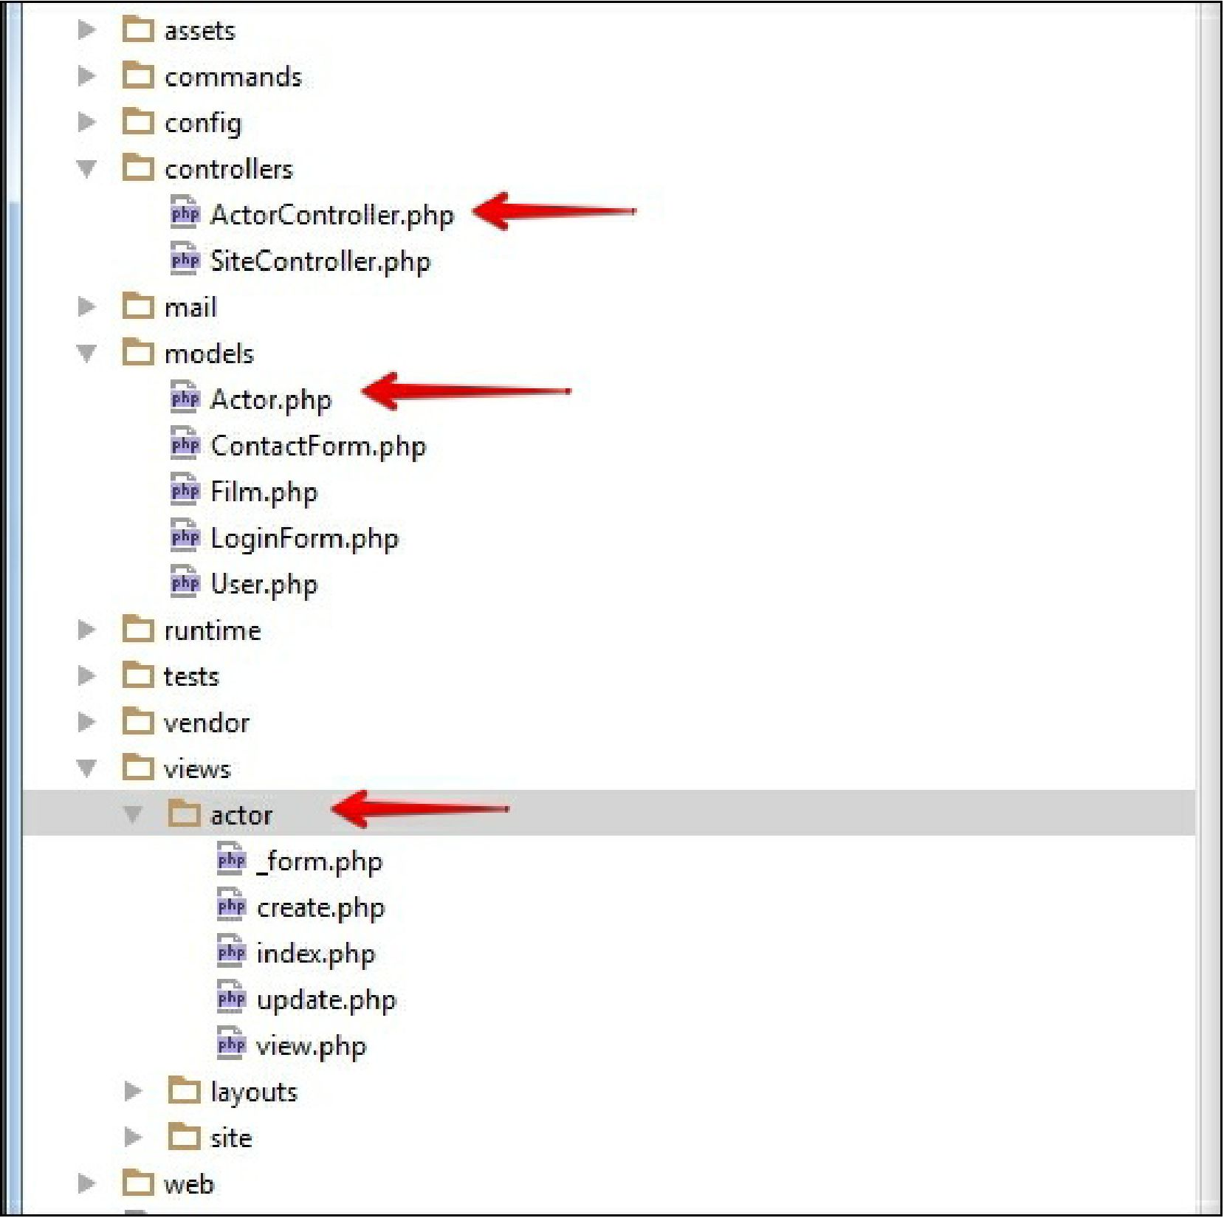

Firstly we’ve created an Actor model. Gii automatically creates all model rules which depends on mysql field types. For example, if in your MySQL actor table’s fields first_name and last_name have is not null flag then Yii automatically creates rule for it required and sets max length 45 symbols because in our database max length of this field is set up as 45.

public function rules()

{

return [

[['first_name', 'last_name'], 'required'],

[['last_update'], 'safe'],

[['first_name', 'last_name'], 'string', 'max' => 45],

];

}